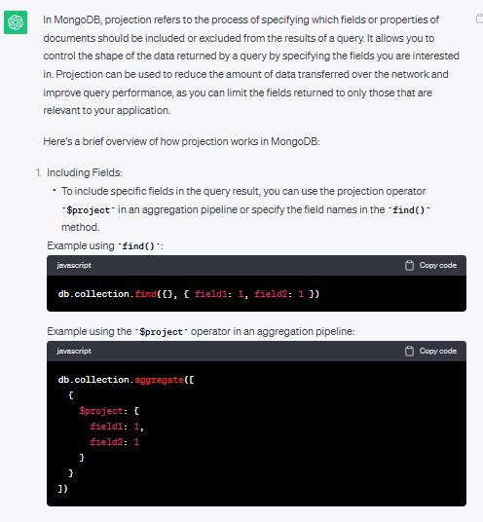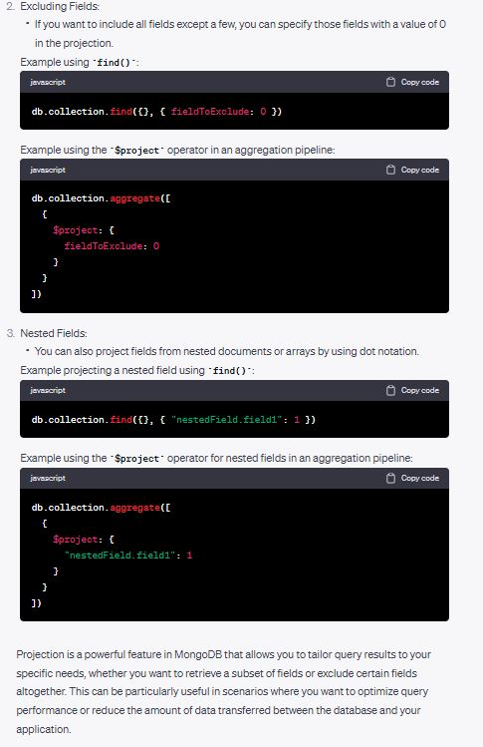

db.passengers.find({meka empty thiyanwa, ethakota okkoma document ekamabalanne},

{pennanna one key walues paire eka})